Step by step Hadoop 2.8.0 installation on Window 10
Muhammad Bilal Yar edited this page on Jun 24, 2018 · 5 revisions

Prepare:
These softwares should be prepared to install Hadoop 2.8.0 on window 10 64bit
- Download Hadoop 2.8.0 (Link: http://www-eu.apache.org/dist/hadoop/common/hadoop-2.8.0/hadoop-2.8.0.tar.gz OR http://archive.apache.org/dist/hadoop/core//hadoop-2.8.0/hadoop-2.8.0.tar.gz)
- Java JDK 1.8.0.zip (Link: http://www.oracle.com/technetwork/java/javase/downloads/jdk8-downloads-2133151.html)

Set up
- Check either Java 1.8.0 is already installed on your system or not, use "Javac -version" to check. 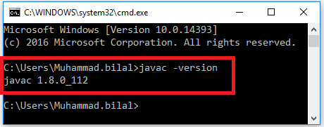
- If Java is not installed on your system then first install java under "C:\JAVA" 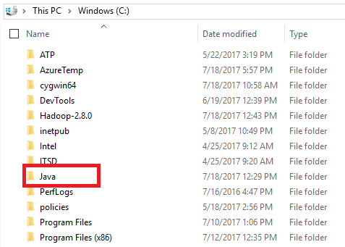
- Extract file Hadoop 2.8.0.tar.gz or Hadoop-2.8.0.zip and place under "C:\Hadoop-2.8.0". 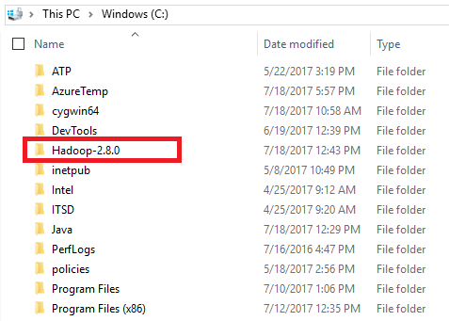
- Set the path HADOOP_HOME Environment variable on windows 10(see Step 1,2,3 and 4 below). 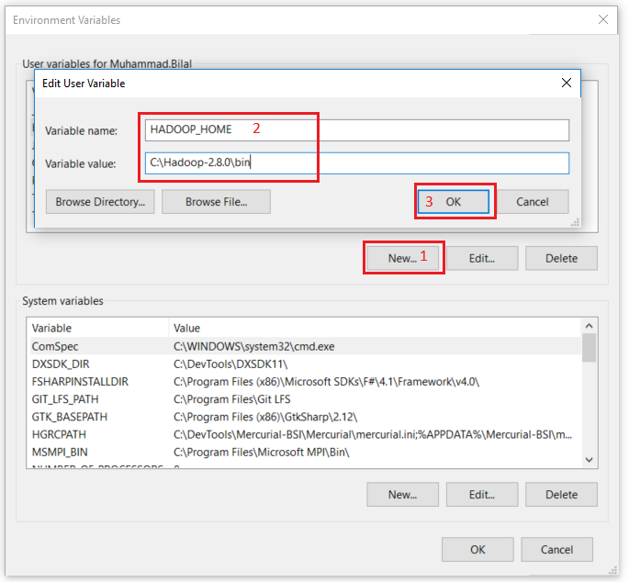
- Set the path JAVA_HOME Environment variable on windows 10(see Step 1,2,3 and 4 below). 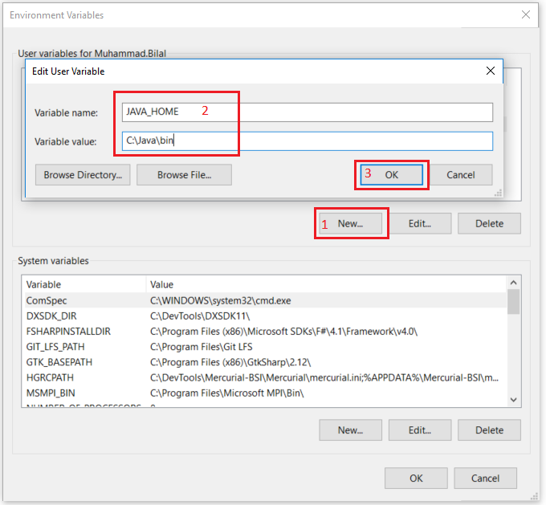
- Next we set the Hadoop bin directory path and JAVA bin directory path. 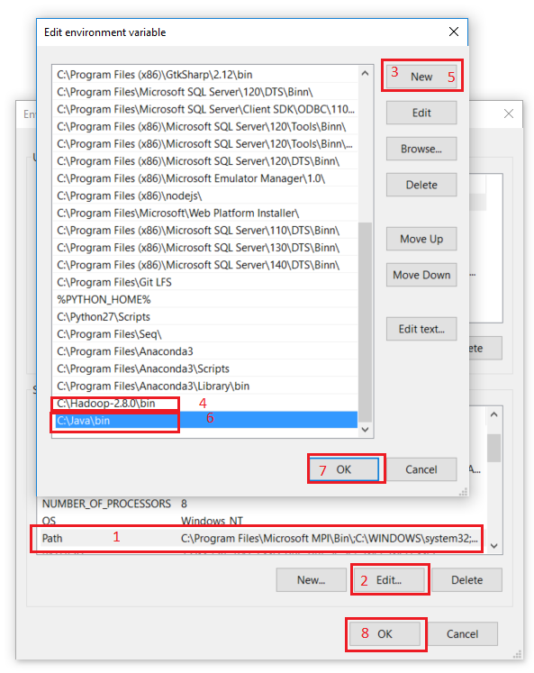

Configuration
- Edit file C:/Hadoop-2.8.0/etc/hadoop/core-site.xml, paste below xml paragraph and save this file.
<configuration>
<property>
<name>fs.defaultFS</name>
<value>hdfs://localhost:9000</value>
</property>
</configuration>
- Rename "mapred-site.xml.template" to "mapred-site.xml" and edit this file C:/Hadoop-2.8.0/etc/hadoop/mapred-site.xml, paste below xml paragraph and save this file.
<configuration>
<property>
<name>mapreduce.framework.name</name>
<value>yarn</value>
</property>
</configuration>
- Create folder "data" under "C:\Hadoop-2.8.0"
- Create folder "datanode" under "C:\Hadoop-2.8.0\data"
- Create folder "namenode" under "C:\Hadoop-2.8.0\data" 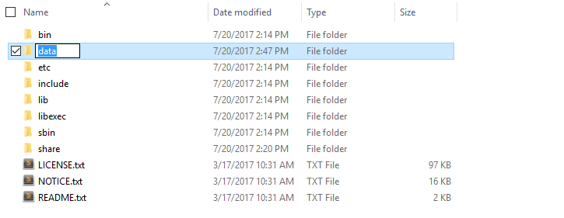
- Edit file C:\Hadoop-2.8.0/etc/hadoop/hdfs-site.xml, paste below xml paragraph and save this file.
<configuration>
<property>
<name>dfs.replication</name>
<value>1</value>
</property>
<property>
<name>dfs.namenode.name.dir</name>
<value>C:\hadoop-2.8.0\data\namenode</value>
</property>
<property>
<name>dfs.datanode.data.dir</name>
<value>C:\hadoop-2.8.0\data\datanode</value>
</property>
</configuration>
- Edit file C:/Hadoop-2.8.0/etc/hadoop/yarn-site.xml, paste below xml paragraph and save this file.
<configuration>
<property>
<name>yarn.nodemanager.aux-services</name>
<value>mapreduce_shuffle</value>
</property>
<property>
<name>yarn.nodemanager.auxservices.mapreduce.shuffle.class</name>
<value>org.apache.hadoop.mapred.ShuffleHandler</value>
</property>
</configuration>
- Edit file C:/Hadoop-2.8.0/etc/hadoop/hadoop-env.cmd by closing the command line"JAVA_HOME=%JAVA_HOME%" instead of set "JAVA_HOME=C:\Java" (On C:\java this is path to file jdk.18.0)
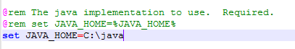

Hadoop Configuration
- Dowload file Hadoop Configuration.zip (Link: https://github.com/MuhammadBilalYar/HADOOP-INSTALLATION-ON-WINDOW-10/blob/master/Hadoop%20Configuration.zip)
- Delete file bin on C:\Hadoop-2.8.0\bin, replaced by file bin on file just download (from Hadoop Configuration.zip).
- Open cmd and typing command "hdfs namenode –format" . You will see 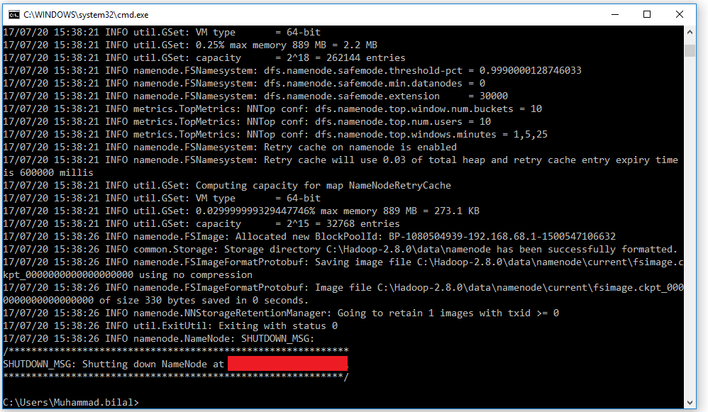

Testing
- Open cmd and change directory to "C:\Hadoop-2.8.0\sbin" and type "start-all.cmd" to start apache. 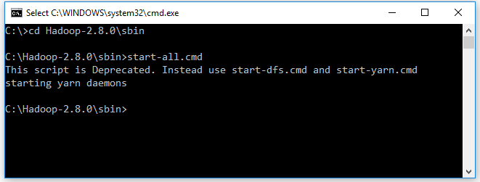
- Make sure these apps are running
- Hadoop Namenode
- Hadoop datanode
- YARN Resourc Manager
- YARN Node Manager 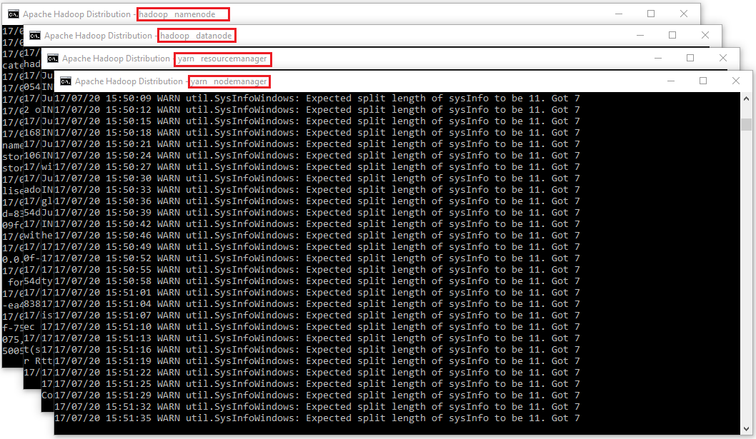
- Open: http://localhost:8088 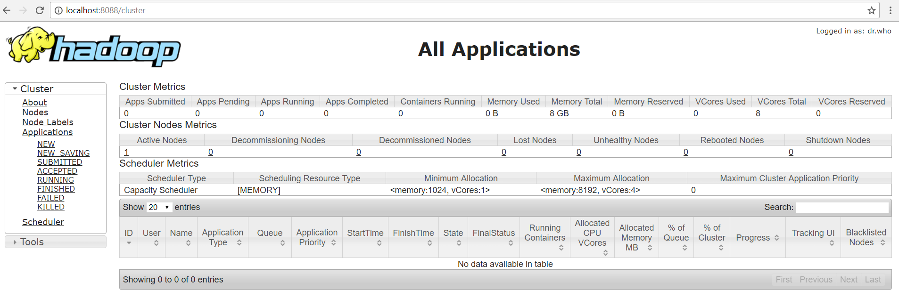
- Open: http://localhost:50070
- 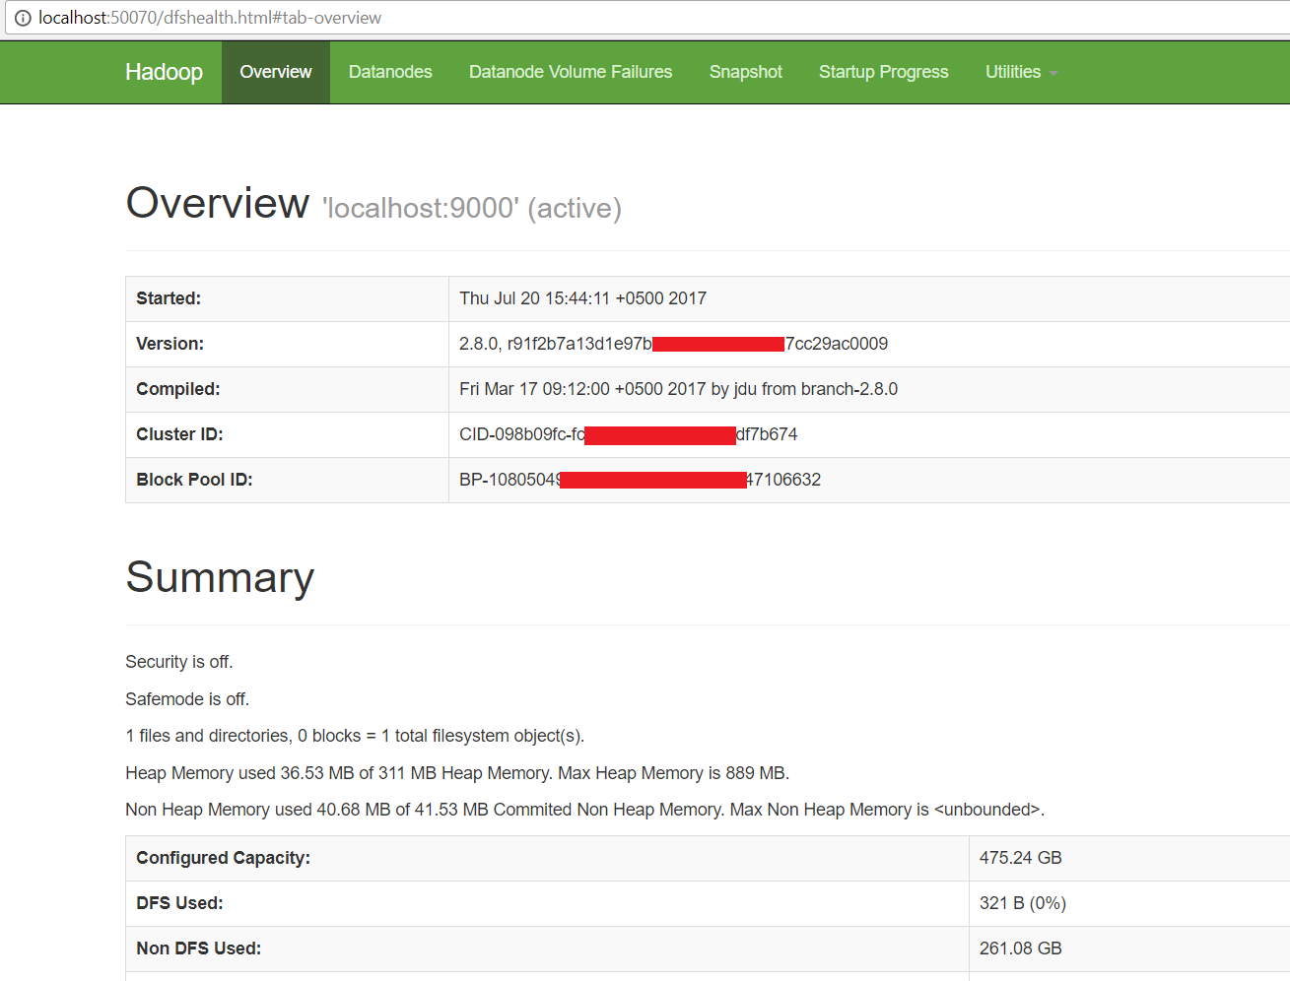

Congratulations, Hadoop installed.
https://github.com/MuhammadBilalYar/Hadoop-On-Window/wiki/Step-by-step-Hadoop-2.8.0-installation-on-Window-10

https://www.youtube.com/watch?v=zujpglKP0Nw

